Excretion, Osmoregulation and Homeostasis
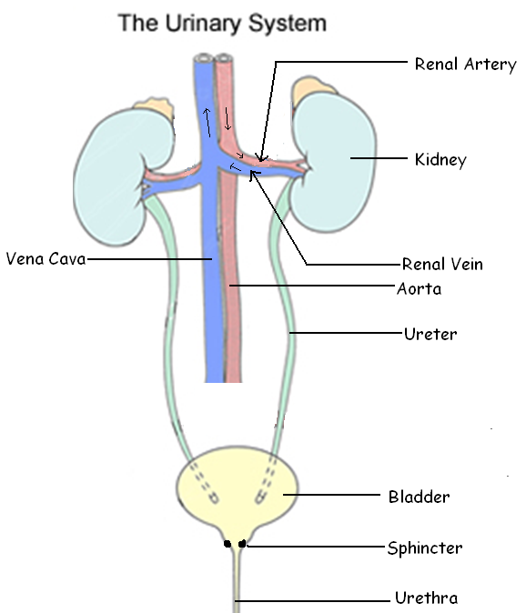
Excretion is the removal of wastes such as urea, excess salts, excess water and carbon dioxide.
Osmoregulation is maintaining the blood at a suitable constant concentration.
Homeostasis is maintaining a suitable constant internal environment.

Each kidney receives a good supply of oxygenated blood from the renal artery. The renal vein takes the deoxygenated blood from the kidneys to the vena cava.
The blood in the renal vein has less oxygen, salt, urea and uric acid than the renal artery. Urine is carried to the bladder along the ureter. A sphincter muscle at the junction of the bladder and urethra regulates the release of urine. Urine is carried out of the body along the urethra.

The nephron or renal tubule is the functional unit of the kidney.
Each human kidney has about one million nephrons which produce urine by filtration and reabsorption
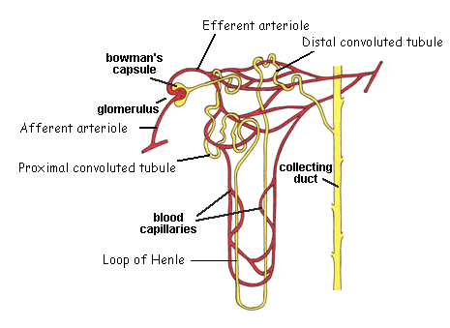
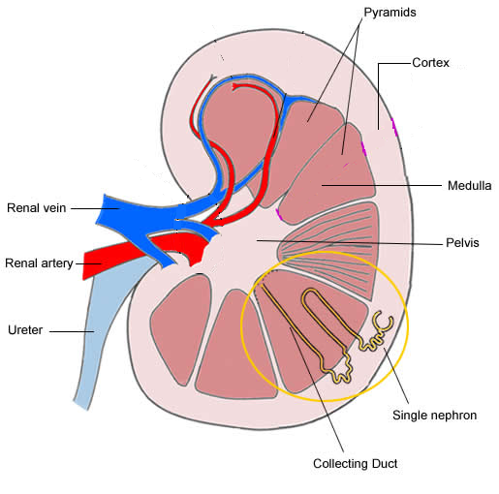

Filtration
The glomerulus functions as a filter. The glomerular capillary walls are porous. The red blood cells, white cells, platelets and plasma proteins are too big to pass through the pores. Therefore the glomerulus filters the blood into Bowman’s Capsule. Glomerular filtrate contains water, glucose, amino acids, vitamins, salts, urea, and uric acid. The blood pressure is unusually high in the glomerulus. The blood pressure is generated by the pumping action of the heart and the efferent arteriole is narrower than the afferent arteriole. This high pressure filtration is called ultrafiltration.

Reabsorption
Much useful material was lost from the blood into Bowman’s Capsule. The ‘useful’ materials are taken back into the blood from the nephron. Urine is the unabsorbed (left behind in nephron) glomerular filtrate.
All of glucose and amino acids and four fifths of the salts and water are reabsorbed in the Proximal Convoluted Tubule. Glucose, amino acids and salts are reabsorbed by active transport. Water is reabsorbed by osmosis.
The Loop of Henle
This structure allows the kidney to reabsorb extra water in times of water stress concentrated than blood plasma. About 5% of the water from the glomerular filtrate is reabsorbed from the Loop of Henle by osmosis. The main function of the Loop is to develop an increasingly concentrated medulla by actively removing salt from the nephron into the surrounding medulla tissue. This allows extra water, if needed, to be absorbed from the collecting duct under the influence of ADH hormone.
Osmoregulation
If the concentration of the blood rises by eating salty food, or water loss due to sweating or inadequate water intake the brain releases ADH into the blood which increases the permeability of the collecting ducts to water. More water leaves the collecting duct by osmosis into the salty medulla tissue and into the blood capillary and a small volume of concentrated urine is produced. If the concentration of the blood falls by drinking too much water then ADH secretion stops, the collecting ducts become less permeable to water and a large volume of dilute urine stays in the collecting ducts. Alcohol and caffeine are diuretics. They inhibit the production of ADH and so cause a large volume of urine.

Skin
Epidermis
The epidermis consists of 3 layers. The Malpighian Layer is the base layer, which is constantly producing new cells by mitosis. The new cells are pushed towards the surface. The dark pigment melanin is produced here. The middle layer is called the Granular Layer the protein keratin accumulates in the cells giving them a granular appearance. The surface layer of dead keratinised (protein) cells, which is constantly being eroded is called the Cornified Layer
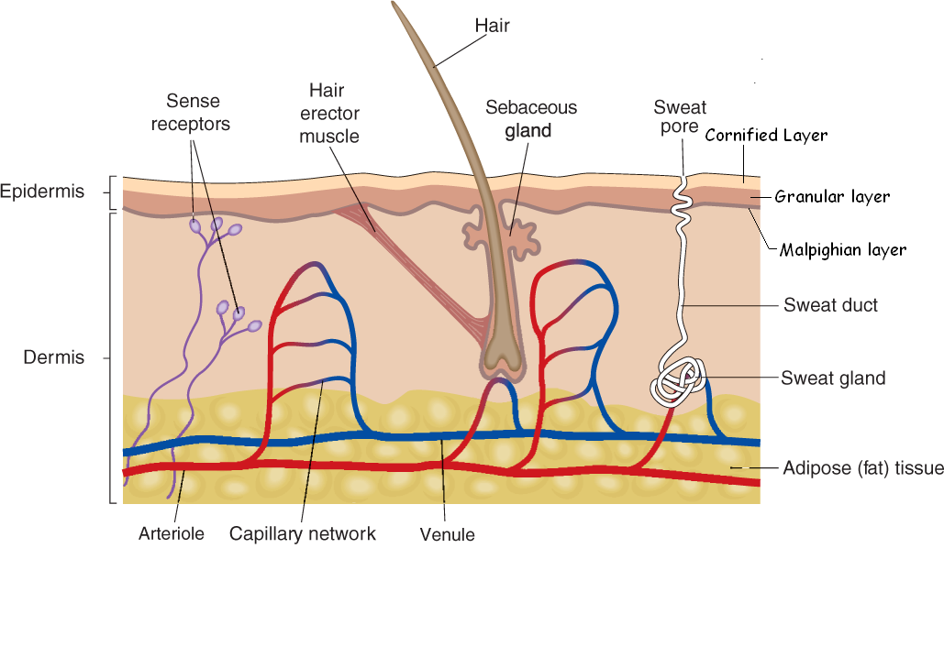
Dermis
The dermis is the inner layer of the skin, above it is the epidermis and below it is adipose tissue.
Many different structures are present in the dermis: hair follicles, sebaceous glands, sweat glands, blood vessels and sensory nerve endings
Functions of the Skin
Prevents excessive loss of water. Prevents the entry of pathogens. Sebum from the sebaceous glands contain anti-microbial chemicals. Melanin gives protection against the damaging UV rays of sunlight. The skin contains receptors for touch, pressure, pain, temperature rise and temperature decrease. Vitamin D is produced by the skin when exposed to ultraviolet light. Sweat allows the removal of waste products such as urea, ammonia, uric acid and lactic acid. Fat storage adipose tissue below the dermis acts as a heat insulator.

Temperature Regulation
When the body is too hot sweat glands secrete water onto the skin surface. Evaporation of water removes heat from the body. Arterioles dilate increasing blood flow through the capillaries close to the skin’s surface. The hair erector muscles relax, the hair lies flatter allowing air to circulate close to the skin surface cooling it. When the body is too cold, Arterioles contract reducing blood flow into the capillaries lying close to the skin. The hair erector muscles contract, the hair rises, trapping a layer of air, increasing the insulation.

